H.T No
Regulations:
A15


Sreenidhi Institute of Science and Technology
(An Autonomous Institution)
Code No: 5AC41 Date: 20-Dec-2019 (FN)

B.Tech II-Year I-Semester External Examination, Dec-2019/Jan-2020 (Supplementary)
Elements of Electrical Engineering (CSE and IT)

Time: 3 Hours Max.Marks:75

Note: a) No additional answer sheets will be provided.
b) All sub-parts of a question must be answered at one place only, otherwise it will not be valued.
c) Missing data can be assumed suitably.

Part - A Max.Marks:25

Answer all QUESTIONS.

1. | Two capacitors of equal capacitance ‘C’ are first connected in series and then in parallel. Find the ratio of equivalent capacitance of the series combination to that of parallel combination. | [3M]
2. | Define i) Amplitude of an alternating quantity  ii) Instantaneous value of an alternating quantity iii) Frequency. | [3M]
3. | Classify the different types of DC Generators based on method of excitation? | [3M]
4. | The emf per turn for a single-phase 2200/220 V, 50 Hz transformer is 11 V. Calculate the number of primary and secondary turns. | [3M]
5. | What are the relation between the Line voltage phase voltage and Line current and phase current in star connected three phase system? | [3M]
6. | Classify electrical measuring instruments? | [2M]
7. | State Kirchhoff’s laws with an example? | [2M]
8. | Represent complex and polar forms and how to convert polar to rectangular form. | [2M]
9. | What is meant by an ideal transformer? | [2M]
10. | What are the advantages of basic measuring instruments (MI)? | [2M]
Part – B Max.Marks:50
ANSWER ANY FIVE QUESTIONS. EACH QUESTION CARRIES 10 MARKS.

11. | a) | Determine the current delivered by the source in the circuit shown in below figure.  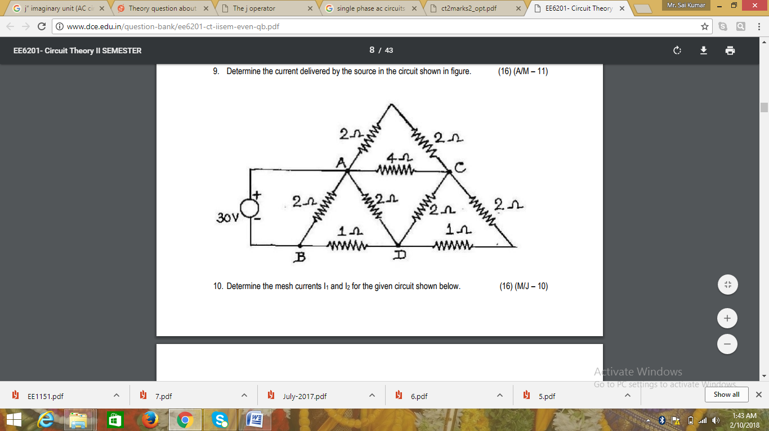 | [5M]
 | b) | Determine the current I from the below circuit diagram.  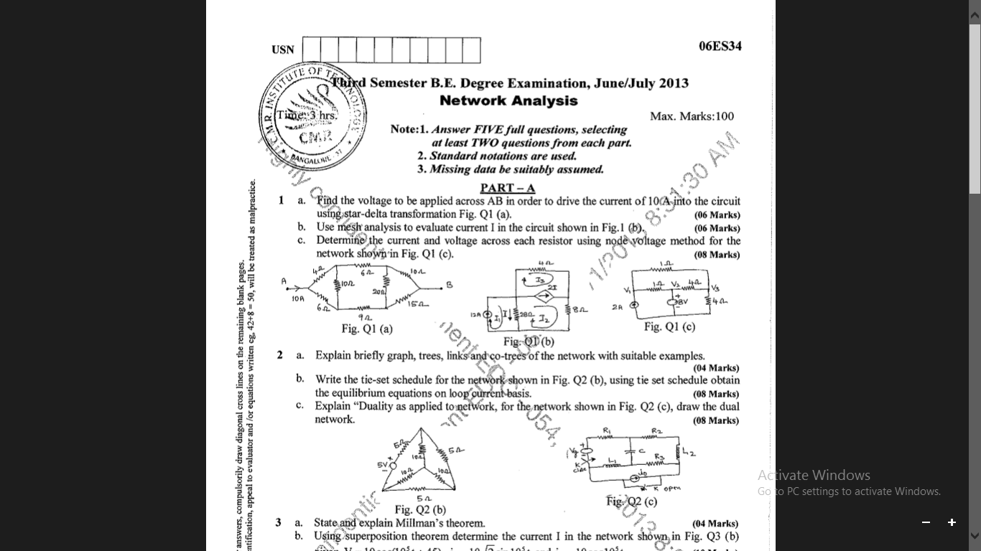 | [5M]
12. | a) | Find the Root Mean Square value, Average value, Form Factor, Peak factor for the wave form shown below.  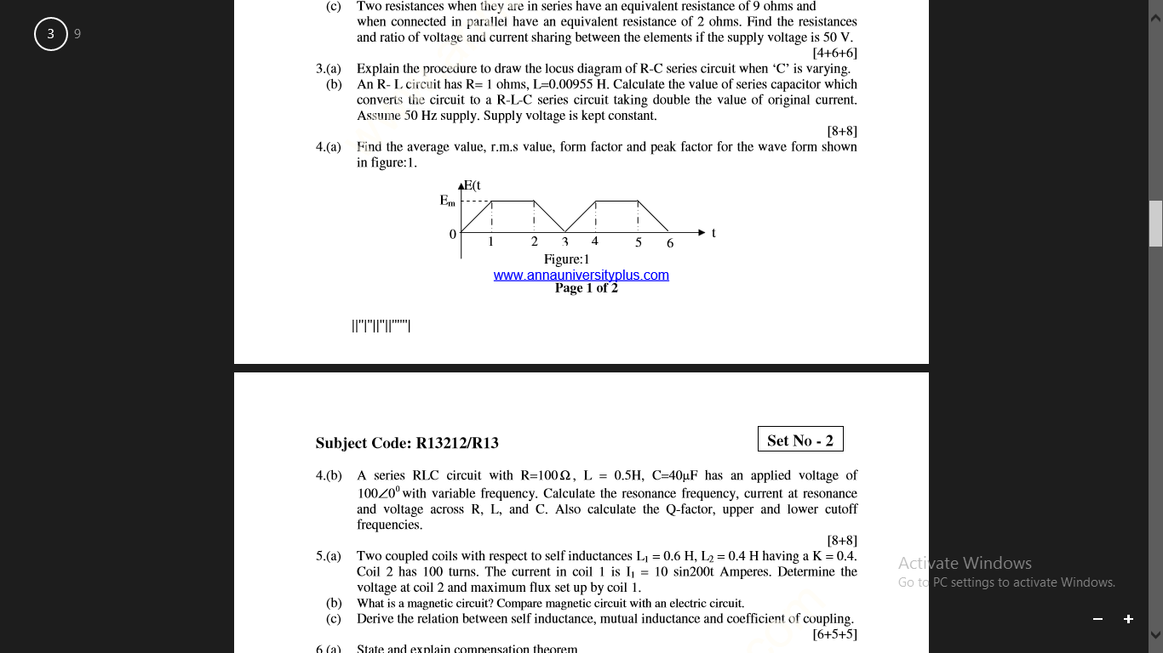 | [5M]
 | b) | Find V_{x} in the network of below Figure, if the current through 2+j3 element is zero.  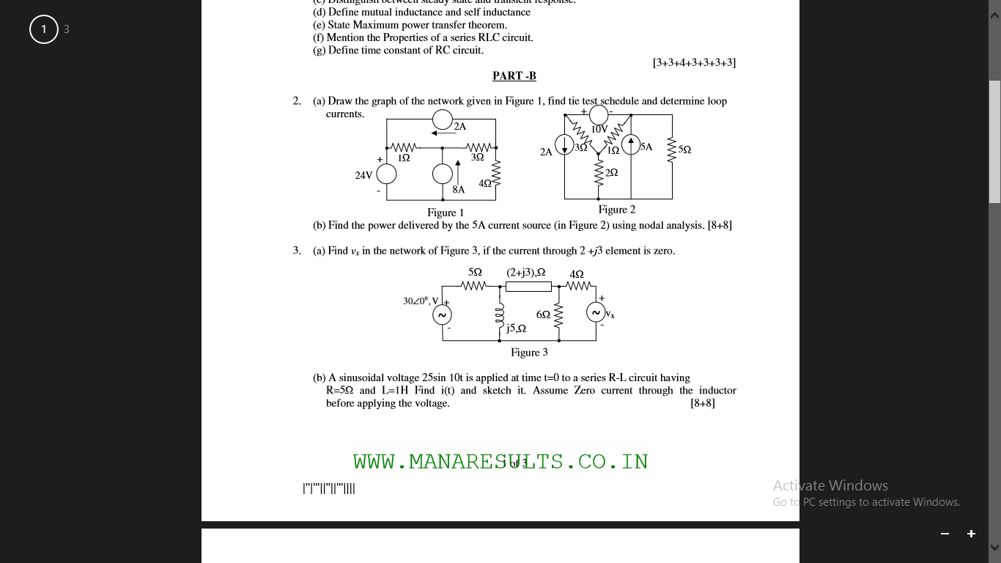 | [5M]
13. | a) | Explain how flux and current will be effect on the Torque in DC motor, Derive its expression? | [5M]
 | b) | In a 400V, DC Compound Generator, the resistance of the armature, series and shunt windings are 10Ω, 0.05Ω and 100Ω respectively. The machine supplies power to 20 Nos. resistive heaters, each rated 500 watts, 400 volts. Identify the induced emf and armature currents when the generator is connected in Short Shunt. | [5M]
14. |  | Explain the operation of a transformer with necessary vector diagrams at  (i) On no load and (ii) On load with UPF, leading and lagging power factors. | [10M]
15. | a) | Draw and explain the torque slip characteristics of the three phase induction motor with different modes of operation? | [5M]
 | b) | A three phase, 415V, 50Hz, 4 pole induction motor has star connected stator winding. The rotor resistance and reactance are 0.2Ω and 2Ω respectively. The full load speed is 1440rpm. Calculate the torque developed on full load by the motor. Assume stator to rotor ratio is 2:1. | [5M]
16. | a) | What are the basic requirements for electrical measuring instruments, Explain? | [5M]
 | b) | Explain the operation of attraction type of Moving coil instrument. | [5M]
17. | a) | State and explain Thevenin’s theorem with example. | [5M]
 | b) | What are the different losses in the DC machine and derive the condition for Maximum efficiency? | [5M]
18. | a) | A 500 KVA Transformer has a core loss of 2200 watts and a full load copper loss of 7500 watts. If the power factor of the load is 0.90 lagging, Evaluate the full load efficiency and the KVA load at which maximum efficiency occurs. | [5M]
 | b) | Derive the expression i) Starting Torque ii) Running Torque iii) Maximum torque for three phase induction motor? | [5M]

-- 00 -- 00 –

